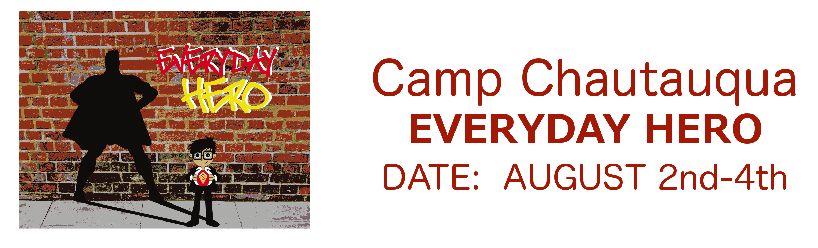
Please complete this form and turn in with your $40 non-refundable Pre-Registration fee due by July 15th – Cost increases to $200 if not turned in by this time.
Camper’s Name____________________________________________________ M_____ F_____
Date of Birth_______________________ Age________ School Grade This Fall _______________
Address____________________________ City ___________________ State _____ Zip _______
Phone (_____)_________________ If No Answer Call (_____)___________________________
Church ___________________________________ Pastor ______________________________
Please List Any Problems Your Teenager Might Have:
____ Hay Fever/Asthma ____ Seizures ____ Diabetes ____ Bee Stings ____ Allergies
____ Medication (Specify) ________________________________________________________
Any Recent Injuries/Operations ____________________________________________________
Date of Last Tetanus Shot ________________________________________________________
Special Instructions _____________________________________________________________
**Medical Insurance Company ____________________________________________________
Contract/Policy Number _________________________________________________________
Company Address _____________________________________ Phone (______)___________
In case of an accident or other emergencies, I hereby grant permission for the Camp Authorized Medical Personnel to administer (or have administered) needed medical attention if necessary.
____________________________________________ _______________________
Signature of Parent/Guardian Date
I agree to abide by the Camp rules and do my best to help make this the greatest week ever!!! ____________________________________________ (Signature of Camper)
To Whom It May Concern: Liability Release Form
Understanding the dangers and hazards of some of the activities this camp offers, I give my permission for _____________________ to participate. I understand that my child is participating at his/her own risk and agree that Chautauqua and the church will be free of any and all liability due to any injury my child may incur while involved in these activities.
Signature of Parent/Guardian ______________________________________

